McKnight Crossings
Govee Temperature and Humidity Review
Data through July 23, 2026
Prepared from 322,997 one-minute readings collected by 14 Govee sensors

Executive Summary
Most monitored areas were maintained in the low-to-mid 70s, with relative humidity generally near 50-55%. Conditions vary materially by zone, so the data does not indicate one uniform building-wide HVAC problem.
The third-floor food-pantry area was consistently the coolest monitored portion of the building, averaging approximately 71.7°F across four sensors. The Canteen and Cafe had the highest sustained moisture levels, averaging 65.3% and 61.9% relative humidity, respectively.
The fourth-floor sensor averaged 74.6°F over the full period and 76.9°F during July 21-23. The Gym was the warmest monitored area overall at approximately 75.3°F.
The A5 Pre-K sensor is located in the front room served by Split Unit 2. It does not monitor the back room served by Split Unit 3. Therefore, normal A5 readings do not contradict the field observation that Split Unit 3 is moving air but providing little or no cooling.

Key Findings
- Third floor and food pantry: Average temperatures ranged from 71.1°F to 72.3°F. These areas may be cooled more aggressively than necessary during unoccupied periods.
- Canteen and Cafe humidity: The Canteen averaged 65.3% RH and the Cafe averaged 61.9% RH. Their average dew points were 60.9°F and 59.6°F, indicating a genuine moisture load rather than high RH caused only by low room temperature.
- Fourth floor: The fourth-floor sensor averaged 74.6°F overall and 76.9°F during July 21-23.
- Gym: The Gym averaged 75.3°F and 57.3% RH, making it the warmest monitored area and one of the more humid zones.
- Auditorium: The Auditorium averaged 73.4°F but showed larger schedule-related swings, periodically falling into the upper 60s.
- Pre-K sensor limitation: The A5 sensor represents Pre-K Front WEST and Split Unit 2. A dedicated sensor should be placed temporarily in Pre-K Back WEST to document Split Unit 3 performance before and after service.

Sensor Summary
Location | HVAC area | Avg Temp | Temp Range | Avg RH | Avg Dew Point
Dry Foods | Split Units 6a/6b | 71.1°F | 66.9-73.0°F | 49.9% | 51.4°F
3rd Floor Roof Access | Split Units 6a/6b | 71.3°F | 65.5-77.2°F | 54.0% | 53.8°F
Food Pantry Foyer | Split Units 6a/6b | 71.9°F | 66.7-74.3°F | 52.0% | 53.3°F
Frozen Foods | Split Units 6a/6b | 72.3°F | 66.4-75.0°F | 48.9% | 52.0°F
Kids Check-in | RTU-8 / Main Hallway | 72.9°F | 70.3-74.7°F | 52.0% | 54.3°F
Canteen | RTU-5 | 73.3°F | 66.7-77.9°F | 65.3% | 60.9°F
Auditorium | RTU-1 / RTU-2 | 73.4°F | 68.0-80.4°F | 51.6% | 54.5°F
North Hall/Pew | RTU-8 / Main Hallway | 73.4°F | 70.3-74.7°F | 51.5% | 54.5°F
Cafe | RTU-5 | 73.6°F | 66.4-79.2°F | 61.9% | 59.6°F
4th Floor | RTU-3 / RTU-4 | 74.6°F | 68.9-77.9°F | 53.5% | 56.5°F
Pre-K Front | Split Unit 2 | 74.8°F | 68.4-76.5°F | 52.5% | 56.2°F
Office | RTU-9 | 74.8°F | 71.1-78.1°F | 51.8% | 55.9°F
Gym | RTU-6 | 75.3°F | 72.5-78.6°F | 57.3% | 59.1°F
Nursery | RTU-7 / Toddler-Infants | 75.4°F | 70.7-77.5°F | 51.1% | 56.0°F

Methodology and Limitations
All raw readings are preserved in the companion Excel workbook. Summary statistics exclude the first two hours after each sensor began recording because handling and initial placement can create artificial readings. Daily averages are based on the remaining one-minute observations. Dew point was calculated using the Magnus approximation.
The sensors measure conditions at their specific locations, not necessarily at the thermostat, return grille, or supply register. Building occupancy, door openings, cooking, outdoor weather, thermostat schedules, and equipment cycling can all affect the results. The analysis identifies patterns and priorities but does not replace mechanical testing by a qualified HVAC contractor.

Temperature Comparison
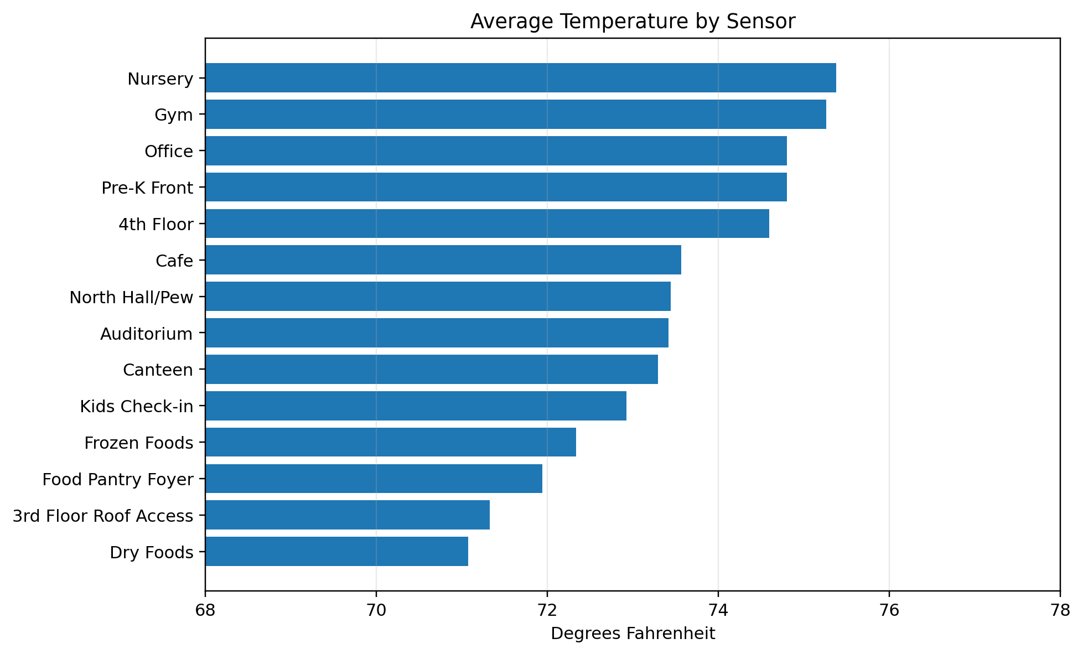
Figure 1. Average temperature by sensor. The third-floor food-pantry sensors are the coolest; the Gym and Nursery are among the warmest overall.

Humidity Comparison
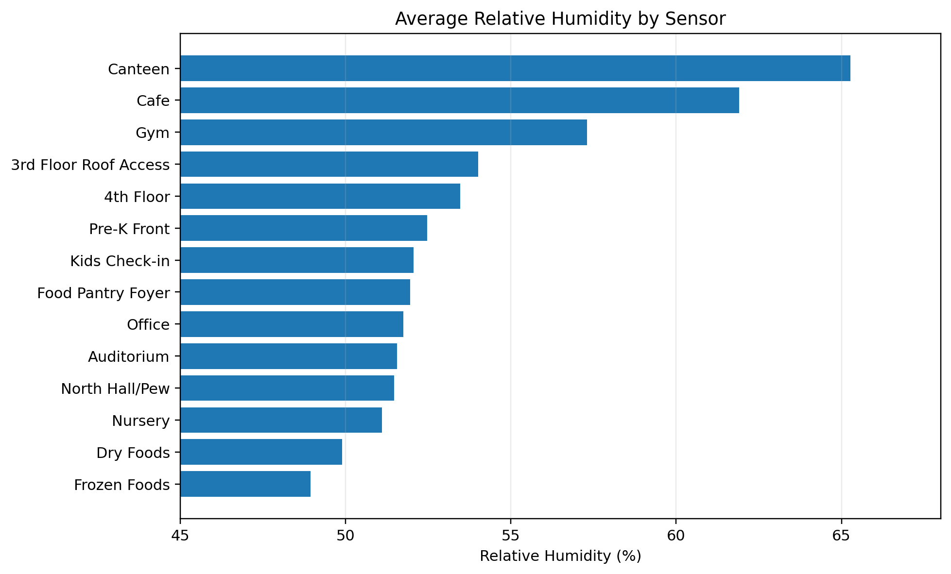
Figure 2. Average relative humidity by sensor. The Canteen and Cafe stand out as the highest-humidity areas.

Daily Temperature Trends
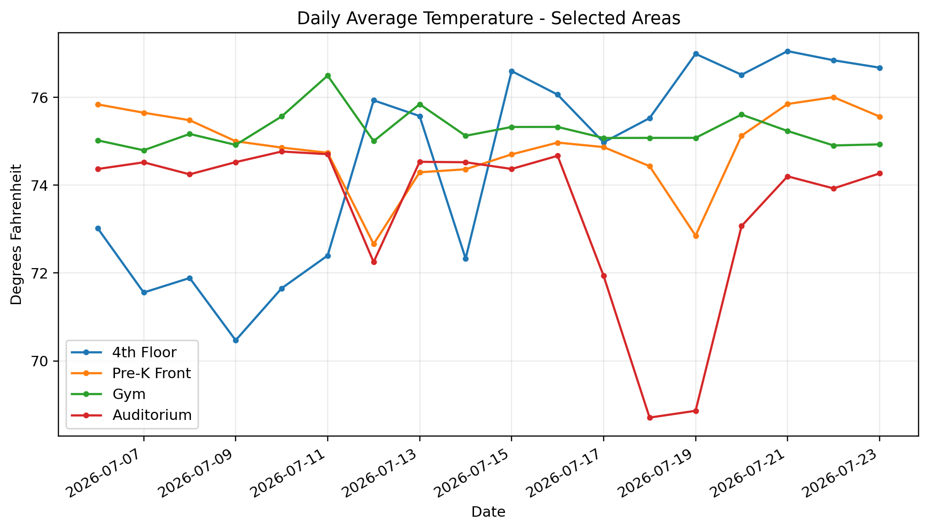
Figure 3. Daily average temperature in selected areas. The fourth floor became warmer near the end of the monitoring period.

Daily Humidity Trends
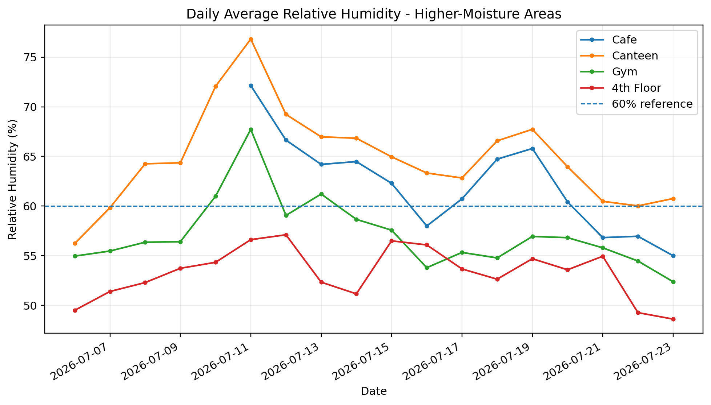
Figure 4. Daily average humidity in higher-moisture areas. The Canteen and Cafe frequently remained near or above 60% RH.

Split Unit 3 - Current Concern
Split Unit 3 serves the Pre-K Back WEST room. During a field test, the thermostat was lowered to 70°F and the indoor blower operated, but the supply air did not feel cool and the room temperature did not decrease after more than an hour. Humidity decreased, which indicates air movement and some moisture removal, but the absence of sensible cooling warrants professional diagnosis.
The outdoor condenser is listed as Carrier model 38CKB042500, approximately 3.5 tons, with an estimated 1996 manufacture date. Because the equipment is roughly 30 years old, the contractor should identify both the immediate fault and whether repair is economically reasonable compared with replacement.
The contractor should document:
- Return-air temperature, supply-air temperature, and the resulting temperature split.
- Whether the outdoor compressor and condenser fan are operating correctly.
- Refrigerant pressures and evidence of a leak or undercharge.
- Evaporator and condenser coil condition, airflow, filter condition, and condensate drainage.
- Repair cost, expected remaining life, and a replacement recommendation if the compressor or refrigerant circuit has a major failure.

Recommended Next Steps
- Proceed with the scheduled diagnostic evaluation of Split Unit 3 and obtain a written temperature-split and refrigerant/compressor assessment.
- Place a Govee sensor temporarily in Pre-K Back WEST so Split Unit 3 can be measured directly before and after service.
- Review the third-floor schedule and consider raising unoccupied setpoints to avoid unnecessary cooling into the upper 60s.
- Investigate the Canteen/Cafe moisture source, including outside-air infiltration, kitchen activity, condensate removal, and equipment runtime.
- Continue monitoring the fourth floor to determine whether the late-period warming is schedule-related, occupancy-related, or an RTU capacity/performance issue.
- Review auditorium schedules to reduce unnecessary pre-cooling while still reaching the desired temperature before services and events.

