**Procedure for Sunday morning security**

February 2025

This memo outlines our procedure for Sunday Morning safety and security.

I have developed a website showing a live feed of several of our security cameras (see **Attachment A**). The security video will be displayed on the computer in the audio room in the back of the auditorium.  If needed, we can also have a similar display out in the foyer as this is a central spot that would allow a single Security Team member to watch the main entrance to the building, the main entrance to the worship area, the kid’s classrooms, AND the security cameras.

With this setup I think appropriate security would be maintained with 1.5 individuals.  My thought is one person would be on main security duty and work the foyer area to monitor activity full-time while church is in session on Sunday (worship and class time).  This individual would need to be walking the facility and around the foyer before and after worship, as well as when the children are released to classes. When no strangers are in the foyer this individual can sit in the back of the auditorium, if wanting to participate in communion and worship. The second individual would watch the security cameras.  This individual would still be mic'd up and would need to be alert of anything curious or alarming in the worship area.

We are also working on an updated safety policy. Draft version available [***here***](https://shared.mxcoc.xyz/2025/2025Feb-MX-SecurityPolicy-draft.pdf).

Give this some thought and I’ll try and schedule a time for the Safety Team to discuss, possibly after worship some Sunday or on a video conference call. Also, always feel free to email with any questions or suggestions: [bret_blackford@yahoo.com](mailto:bret_blackford@yahoo.com).

Appreciate all your service!!

--- Bret

M Bret Blackford

[Bret_Blackford@yahoo.com](mailto:Bret_Blackford@yahoo.com)

**Attachment A**

Below is a screen-shot from the MX security camera website that was developed to be used by the MX Security Team. Intent is that this access to live video will allow better security monitoring on a Sunday morning. This security video is displayed on the computer in the audio room at the back of the auditorium.

We currently have 7 cameras in the high-traffic areas. More cameras can be added if deemed appropriate.

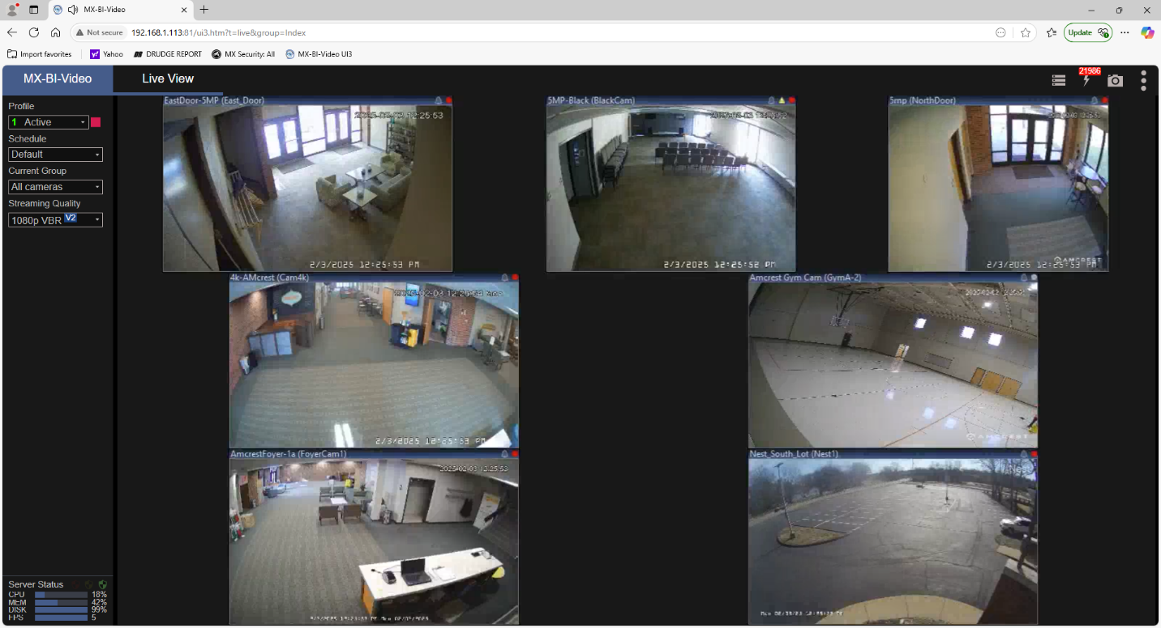

**Attachment B**

**The need for security:**

Houses of worship face a variety of security concerns due to their open and welcoming nature. **Some key security risks include:**

**Physical Threats**

1. **Violent Attacks** – Places of worship have been targeted for shootings, bombings, and other violent acts.
2. **Vandalism & Hate Crimes** – Religious institutions can be targeted for graffiti, property damage, or arson.
3. **Theft & Burglary** – Churches often contain valuable equipment, donation money, and historical artifacts that can attract thieves.
4. **Disruptive Individuals** – Unruly visitors, protestors, or those with mental health issues can cause disturbances.

**Child & Congregant Safety**

1. **Child Protection Concerns** – Churches must ensure safe environments for children, including screening volunteers and preventing abuse.
2. **Medical Emergencies** – Congregants may experience medical crises requiring trained personnel and emergency response plans.

**Operational Security**

1. **Emergency Preparedness** – Churches should have plans for fires, natural disasters, and evacuations.
2. **Access Control** – Managing entry points and securing doors without discouraging visitors.

**Mitigation Strategies**

* **Security Teams & Training** – Train volunteers and staff in emergency response.
* **Surveillance & Lighting** – Install cameras and ensure adequate lighting around the property.
* **Cybersecurity Measures** – Use strong passwords, two-factor authentication, and train staff on online threats.
* **Background Checks** – Screen volunteers and staff, especially those working with children.
* **Access Control** – Lock unused doors, limit key access, and monitor entrances.

**Attachment C**

|  |  |  |
| --- | --- | --- |
|  | Feb-25 |  |
| **McKnight Crossings Church** | | |
| **Safety Team** | | |
| **Name** | **Primary Email** | **Phone Number** |
| **Jayson Vincent** | jayson.t.vincent@gmail.com | (517) 819-7805 |
| **Jeff Fogarty** | Jeff@fogarty.org | (314) 753-2279 |
| **Rick Salley** | ricray57@gmail.com | (314) 630-7886 |
| **Eric McPherson** | emcpherson@cfserve.org | (314) 304-4831 |
| **Judy Miller** | [judy.mzzthang.miller@gmail.com](mailto:judy.mzzthang.miller@gmail.com) | (314) 401-6150 |
| **Robert Willeford** | RobertJrVWilleford@att.net | 214-326-1466 |
| **Linda Mueller** | [lmueller5217@gmail.com](mailto:lmueller5217@gmail.com) | (636) 296-2973 |
| **Jim McCoy** | jmac100@sbcglobal.net | (314) 973-3788 |
| **Kirk Kasicki** | Kirk.Kasicki@gmail.com | (314) 805-6179 |
| **Bret Blackford** | [Bret_Blackford@yahoo.com](mailto:Bret_Blackford@yahoo.com) | (314) 402-7086 |
| **Steve Borth** | scmcs@sbcglobal.net | (314) 540-6290 |
| **Steve Jones** | [jonesy.steve69@gmail.com](mailto:jonesy.steve69@gmail.com) | (314) 323-4579 |
| **Ron Orick** | [rcorick00@gmail.com](mailto:rcorick00@gmail.com) | (479) 653-8585 |
| **Jim Patterson** | jPatt71@outlook.com | (314) 629-9141 |
| **Michael Cannon** | [familycannon3@gmail.com](mailto:familycannon3@gmail.com) | (314) 240-6154 |

|  |  |  |
| --- | --- | --- |
| **McKnight Crossings Church** | | |
| Medical Assistance | | |
|  |  |  |
| Name | Mobile # | email |
| **J. Collins Corder** | **314-307-1093** | jcorder20@gmail.com |
| **Cas Grimshaw** | **314-736-0788** | cgrimsha@gmail.com |
| **Shannon Miller** | **618-975-1607** | [millernum7@gmail.com](mailto:millernum7@gmail.com) |
| **Brett Ferguson** | **314-484-0537** | brettaferguson@yahoo.com |